KENDRIYA VIDYALAYA KAMLA NEHRU NAGAR GHAZIABAD
Autumn break homework
SHIFT- II
CLASS-I
English
1-Take a walk around your house with your family members. Look at small insects and animals, what they do, what they eat, how many different colors they are.After coming home, draw and pictures of any two and say 2 small lines on them . Write their names.
(To be done on A-4)
2-Write 10 words each consisting of ap, at, am , en, et, eg in english copy.
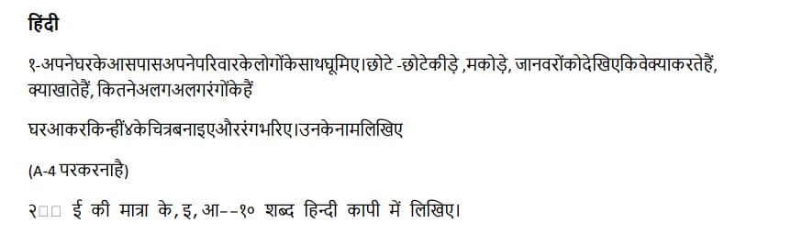
EVS.
1-Collect the leaves of 5 different types of plants.Dry them by keeping them between sheets of paper. Paste them in your scrap book
2- Learn the parts of plant
Maths
1 Learn and Write number names one to twenty
(To be done on maths notebook)
2- Do 10 sums each of addition and subtraction of single digit with match stick or icecream stick as we did with bindis in class in A4 sheet

CLASS - 2
SUBJECT - EVS
1 ) Which festival do you like most ? write five lines about its .
2 ) Write five religious festivals name and paste their pictures .
3 ) Write the name of three harvest festivals and paste their pictures.
4 ) Write the name of three national festivals and paste their pictures.
5 ) Write the difference between -
A ) Diwali and Holi .
B ) Gurpurb and Christmas .
C ) Bihu and pongal
D ) 15th August and 26th January
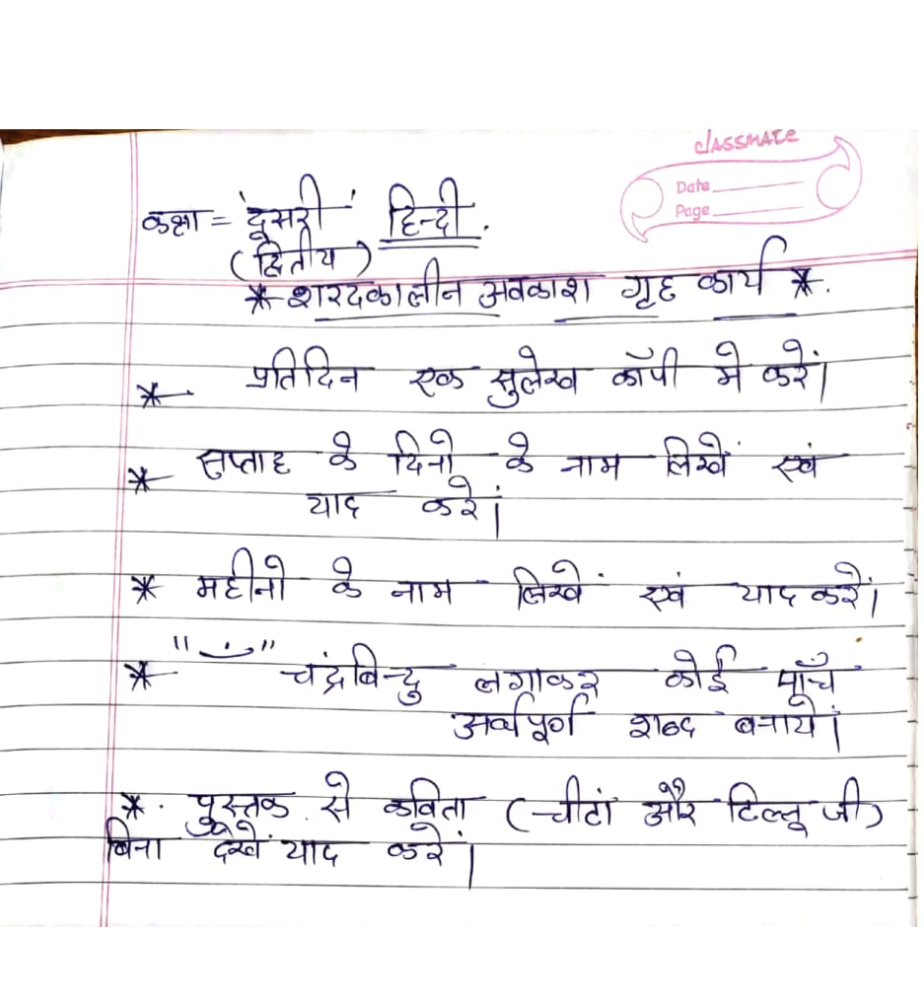

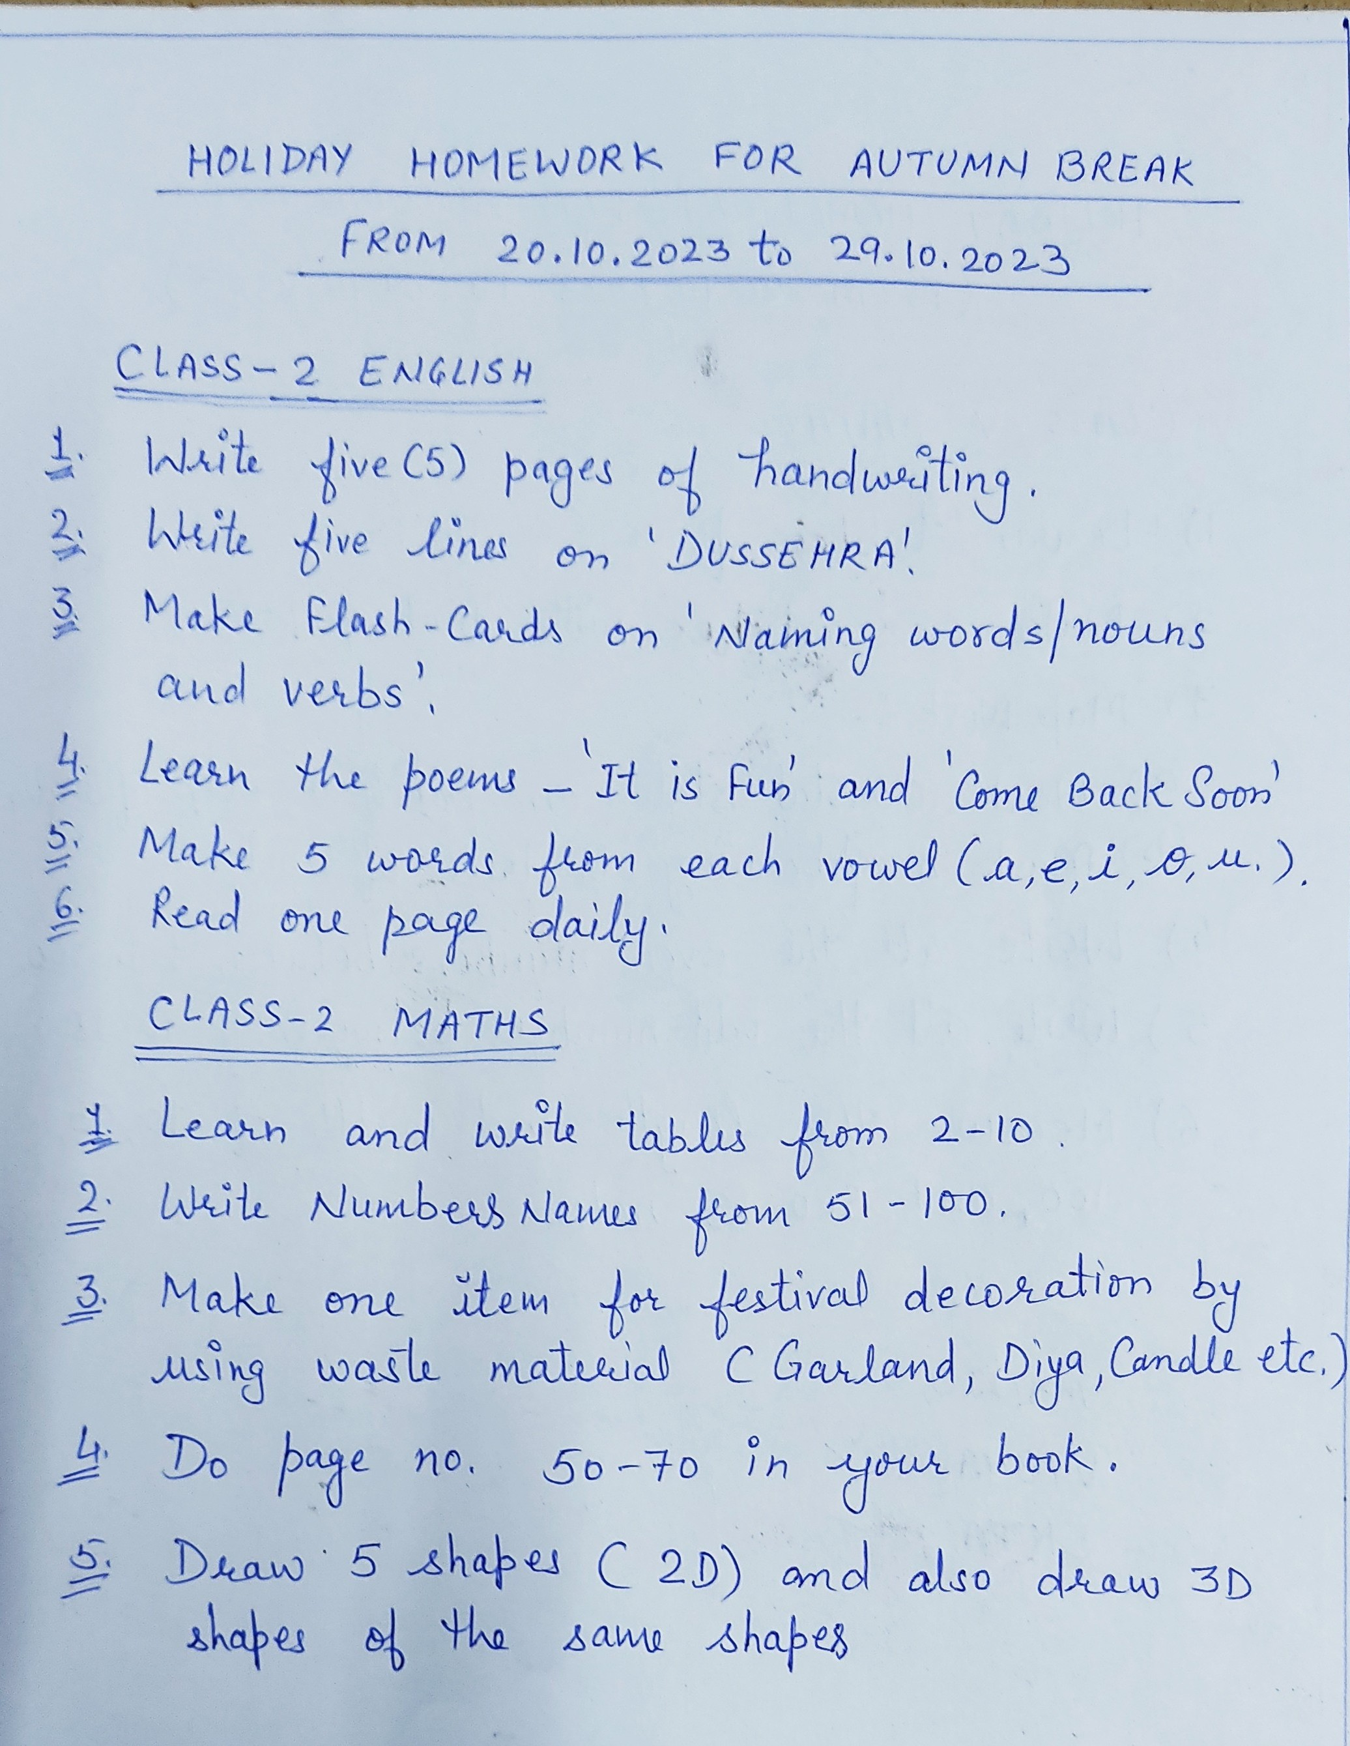

CLASS III
ENGLISH
Learn all the work done of UNIT 6 chapters -
Trains and the Story of road.
*Draw or paste any one mode of transport in your c.w.copy
*Go to visit Dussehra or any fair.
Learn 5 sentences on the above topic for oral activity in the class after the break.
“Happy Holidays “

हिन्दी
पाठ कब आऊँ और क्यूजीमल कैसे कैसलिया
दोनों पाठों का काम जो कॉपी और किताब मैं करवाया है उसको याद करके आना है।
*आपके घर की रसोई मैं जो चीजें हैं उनमे से किन्हीं पाँच के चित्र बनाओ या चिपकाओ और वो किस काम आती हैं ये भी लिखो एक अलग पेपर पर।
*दशहरा का मेला देखने जाओ और वहाँ आपनेजो देखा वो एक अलग से पेपर पर लिखो।

EVS
1.Visit to your nearby post office.Carefully observe the work done by each person.
Buy a post card and write a message to your grandmother or grandfather and post it in the letter box.
2.Make any five different items with modelling clay.( e.g. utensil,bird,animal,fruit,vehicleetc)
3.Play different games with your friends or family members.Learn the rules involved in these games.
e.g chess, hopscotch, basketball etc.
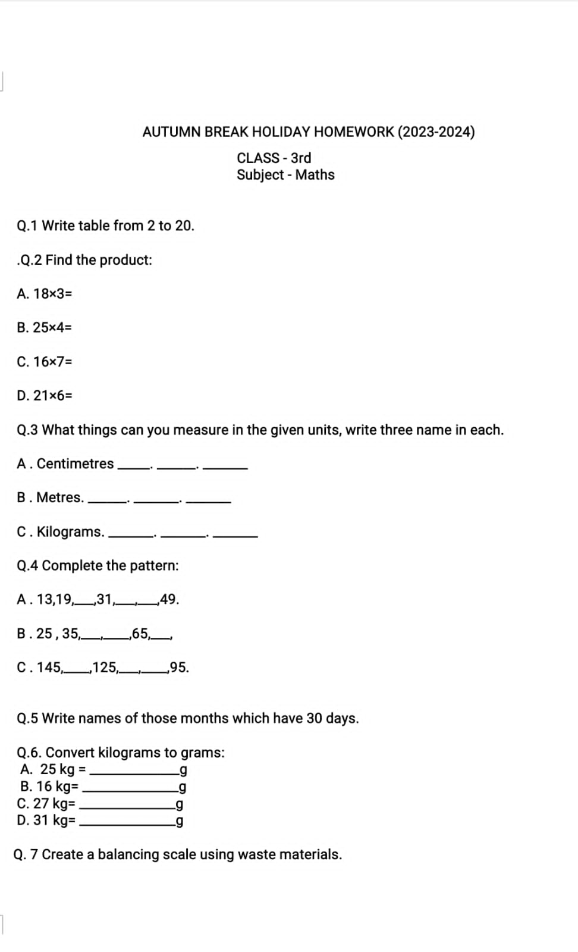

Class-IV
ENGLISH
1. Read the newspaper regularly during the holidays and cut one picture daily from old newspapers paste them in A4 size paper and give a catchy caption to each picture.
2. Find two new words daily from the newspaper and find out their meaning, synonyms and antonyms.
3. Write a paragraph of 150 words or 15-20 lines on the following topics:
a) My plans for Autumn break
b) How I celebrate dussehra
c) My favourite game
d) A picnic day
4. Read one lesson daily and underline the difficult words and write down their meanings.
5. Describe your meals in a day in 50-60 words.
All holiday homework is to be done in A-4 size sheets and make a file of your English Holiday homework.
Maths
- Use white sheet for doing all work.
- Grades will be given for holidays homework.
1) Practice multiplication
A). 4567 x 709
B). 7845 x 649
C) 9834 x 678
D). 7606 x 407
2.) Use your own creativity to show following fraction by different shapes.
1/2
3/4
1/4
Q3) Make 5 different patterns by collecting dry leaves, dry flower etc.

Q4) Make a magic tower by numbers as shown on page 112.

Q5) Make group of 4 objects as shown on page 120.

हिन्दी
1 )एक से सौ तक की गिनती हिंदी में शब्दों में लिखों और याद करो I
2 )रोजाना के दो मुख्य समाचार हिंदी में लिखों I
3 )महात्मा गाँधी का सुंदर चित्र बनाकर ( चिपकाकर ) उनके बारे में पांच वाक्य लिखों I
4 )आपके घर में कौन कौन से शरारती जीव है I उनके चित्र बनाकर ( चिपकाकर ) लिखों की ये आपके घर में क्या- क्या नुकसान करते है ?
5 ) ‘ दशहरा ‘ के त्यौहार का सुंदर चित्र बनाकर ( चिपकाकर ) इसके बारे में पांच वाक्य लिखो I

Subject EVS
1) Locate all states of India in map ( political).
2) Observe nest of different birds. List the material they used in making these.
3) Observe the following about birds and draw on sheet.
Bird feet
Bird beak
4) Make a poster on ...Save water.
5) Make a list of food items you have eaten in the break.

Class V
English
In a scrapbook, paste pictures of any 5 sea creatures and write sentences on any one of them.
Design and decorate a greeting card for any one occasion - Birthday, anniversary, best wishes etc. And write 4 line message in it.
EVS
- Paste picture of any five astronauts in notebook. Also write their achievements .
- Search information about Sunita Williams , Rakesh Sharma and Kalpanachawla . Write short note on each
- Draw all the phases of moon .
- Make a posters on ‘ Save Oil ‘
- Draw or paste any two vehicles according to the following table
Vehicles used petrol | Vehicles used diesel | Vehicles used CNG | Vehicles that do not use oil

6 ) Paste political map of India and show all the states in map .
7 ) write the name of states that are called seven sisters .

